**Issue Years (Background to rest of analysis)**

* T20: Median is 2014 and mean is 2013
* Whole life: Median is 2017 and mean is 2016
* 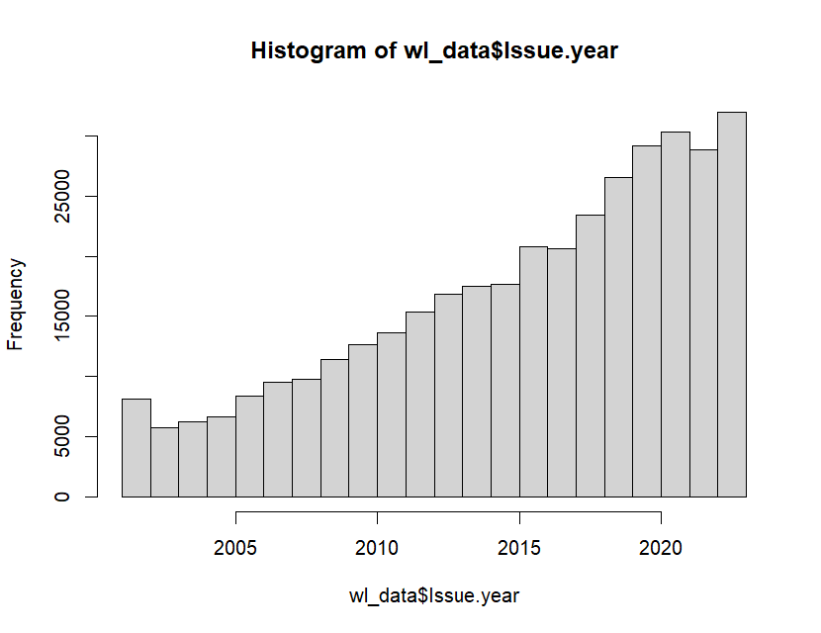Whole life issue yr distribution
* 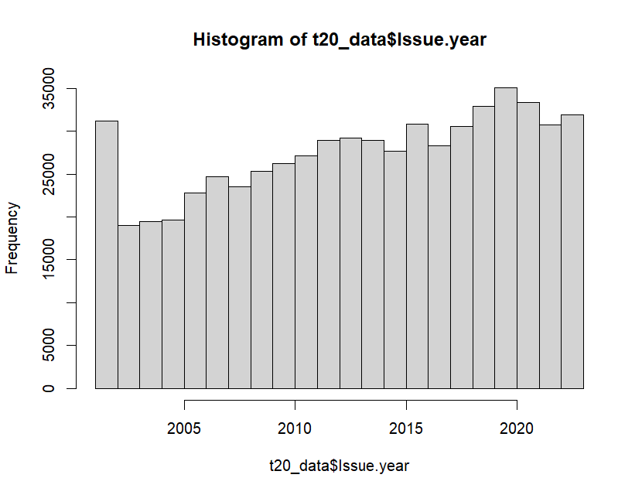20-year term issue yr distribution
* Surprisingly shift towards whole life in more recent years compared to 20-year term issuing date in past 20 years in 2023
  + In past 5 year, 163,997 new 20-year term issuers vs 146,995 new whole life issuers
    - Despite inforce data having 371,301 whole life and 607,281 20 year terms
    - Obvious, proportional shift towards whole life in 2019-2023
    - May be to do with aging population – though life expectancy has not improved

**Age**

* Graph showing actual SuperLife proportions from sample of whole life and 20 year life insurance excluding ages 0-24 years as customer targets.
* 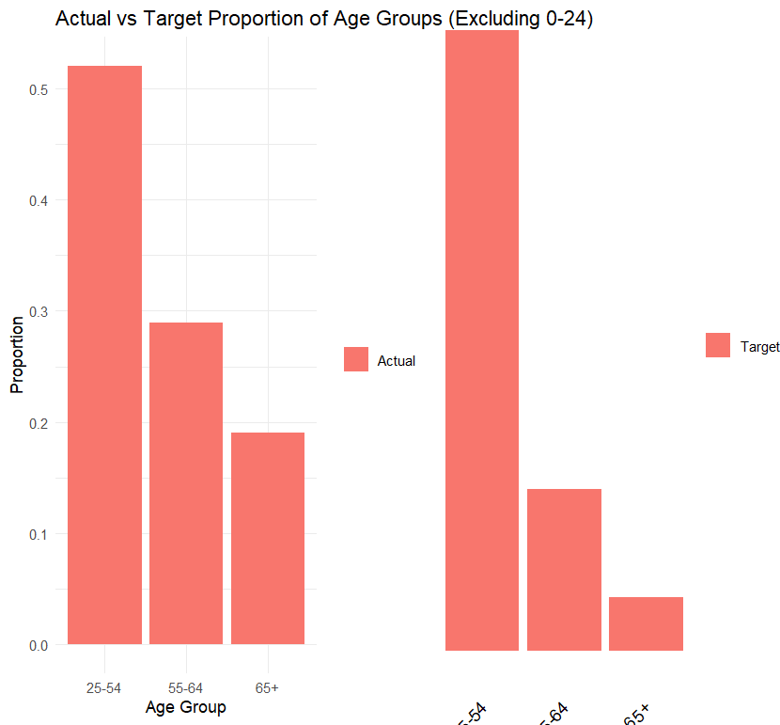
* 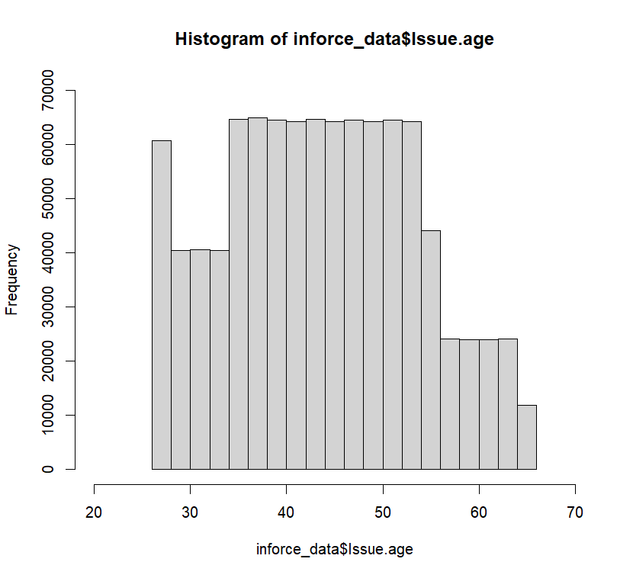
* 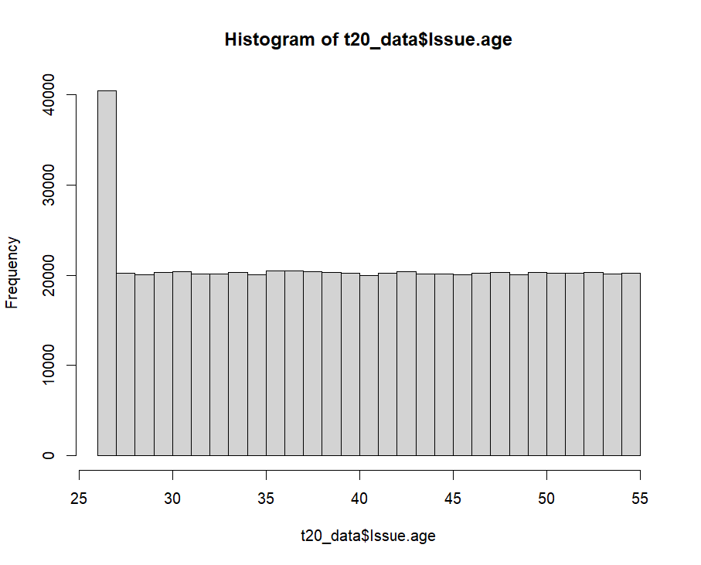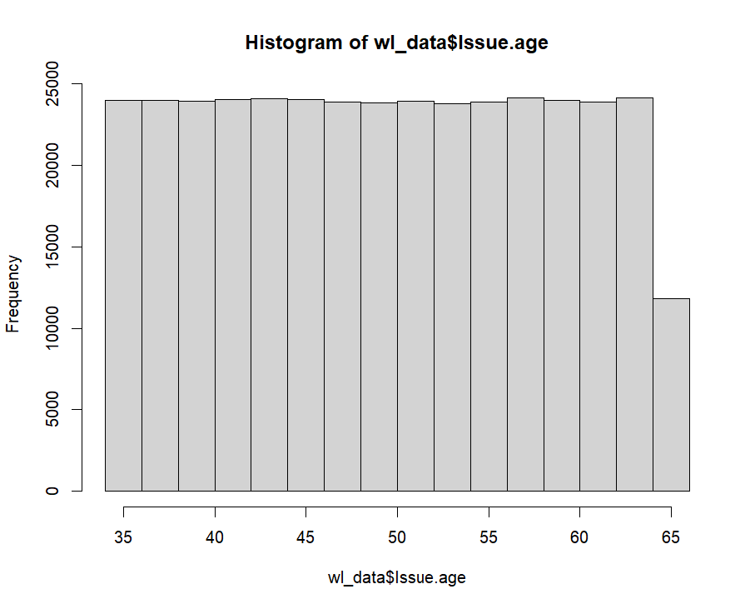
* Whole life: age ranges from 35-65 years
  + Similar frequency in age range and for off at 65
  + Increase in whole life purchases in recent years
* Term 20 years: 26-55 years
  + Large jump in the number from age 26 new issue age
* Unable to exploit past 5 year change cause there is no change

Conclusion: Aim for older years in regard to whole life insurance. If considering older ages, whole life should be aimed with the increased popularity of the product in the past 5 years.

* Intervention programs related to age: Active Aging program, discounted gym program, fitness tracking incentives, parenting support, healthy eating campaign
  + Due to expenses or lack of data and aim for younger demographic → fitness tracking incentive, healthy eating campaign or parenting support

**Distribution channel**

* 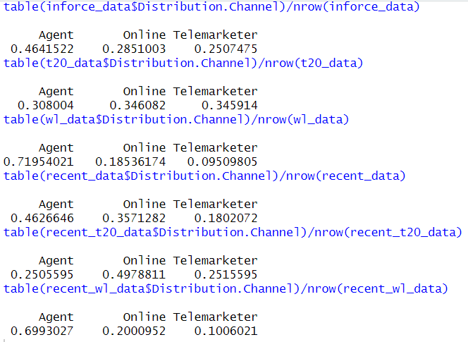
* T20: 50.2% commission
* WL: 80.0% commission
* Shift from past 20 years of 28.5% online distribution and 25% telemarketer to past 5 years of 35.7% online and 9.5% telemarketer
  + Past 5 years: T20 has had 5% declining reliance on agents from past 20 year trend and 15% increase in discovery from online
  + Past 5 years: WL has had a stable large approx 70% reliance on agent, with only a 1.5% chance in increased online
  + May be the difference in age targeting with WL for older generations and T20 for younger and accessibility of online resources

Conclusion: for pricing/cost purposes and program design must consider WL stable reliance on agent and T20’s increasing reliance on online distribution channels. Agent or lack of agent commission pricing must be considered as well as the complexity of product design due to differing channel distribution.

**Smoking**

|  |  |  |
| --- | --- | --- |
|  | **Non-smoker** | **Smoker** |
| General past 20 years | 93.7% | 6.3% |
| General WL past 20 years | 97.5% | 2.5% |
| General T20 past 20 years | 91.4% | 8.6% |
| Recent 5 years | 96.2% | 3.8% |
| WL past 5 years | 99.3% | 0.7% |
| T20 past 5 years | 93.5% | 6.5% |

* In the SuperLife data (above 18), there is 6.3% smokers compared to the population of 18% smokers above 18
  + Furthermore past 5 years only 3.8% smokers in SuperLife sample
    - Recently WL only 0.7% smoke
    - Recently, though T20 has 6.5% smoke
  + Huge market potential here - most whole life are older despite generally smokers being on the older range (external data required)
    - Furthermore, with WL having a higher proportion of very low and low risk compared to T20

Conclusion:

* Intervention programs related to smoking: Online health, heart health screenings, community fitness challenges, incentive prevention, cancer prevention, smoking cessation, healthy eating, hiking

**Underwriting Risk Evaluation**

* 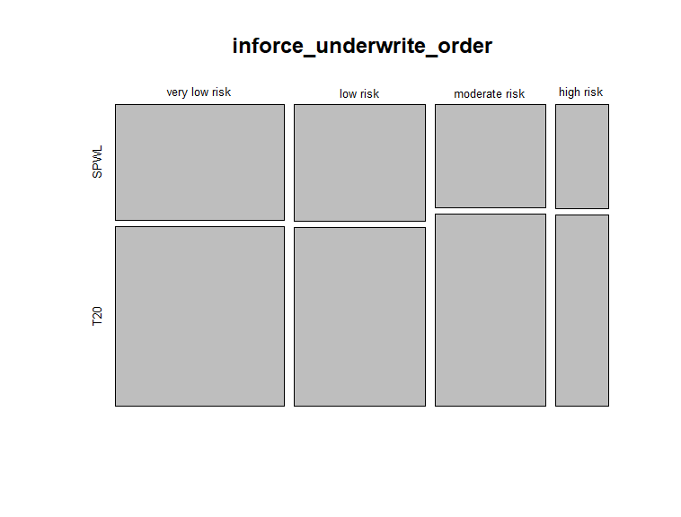
  + Whole life tends to have more very low and low risk compared to 20-year term proportionally
  + Not much change in proportion past 5 yrs
    - Shift from moderate risk towards very low risk by a small percentage at most - considering lower life expectancy of 78.5 from 2010 vs 78.4 2023

**Gender**

* Higher distribution of males with 44% females and 56% males
  + 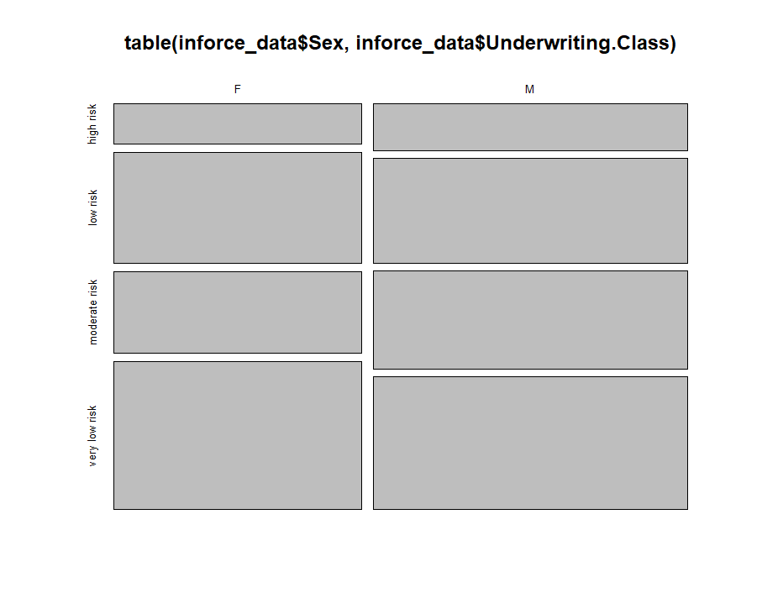
    - Males tend to have higher moderate or high risk proportionally to women
  + Notably, females have a lower 41.7% and males a higher 58.3% distribution in whole life
    - Hard to take advantage of cause most interventions are not gender related or lack data on it

**Urban vs Rural**

* Similarly unable to take advantage of in regard to confirming higher risk individuals correlating to this variable - both in terms of smoking and also underwriting risk